Task-5: Multiple Y-Axes Sharing a Common X-Axis Plot
- Description
Create a plot with multiple y-axes sharing a common x-axis.
- Output
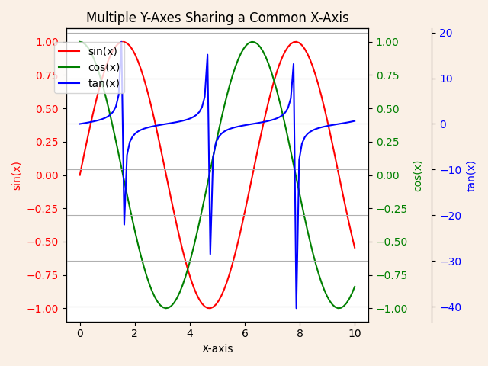
- Algorithm Used in Task
This code creates a plot with a shared x-axis and three distinct y-axes for sin(x), cos(x), and tan(x). Each function is displayed in a unique color for easy differentiation. The y-axes are customized to ensure they do not overlap, making the visualization clear and insightful. The plot is styled with a background color, gridlines, and legends, then saved as a PNG file for future reference.
Explanation of Libraries and Their Usage:
- Matplotlib (import matplotlib.pyplot as plt)
  - A Python library for creating static, animated, and interactive visualizations.
  - Key Functions Used:
    - plt.subplots(): Creates a figure and a single axis for plotting.
    - ax.twinx(): Creates additional y-axes that share the same x-axis.
    - plt.savefig(): Saves the plot as a PNG file.
- NumPy (import numpy as np)
  - A library for numerical computations.
  - Key Functions Used:
    - np.linspace(): Generates an array of evenly spaced values.
    - np.sin(x), np.cos(x), and np.tan(x): Compute trigonometric functions.
Approach
- Generate xxx-values using np.linspace() and compute corresponding yyy-values for sine, cosine, and tangent functions.
- Create a single x-axis shared by three separate y-axes to display sin(x), cos(x), and tan(x) on different scales.
- Style the plot with custom colors, legends, gridlines, and labels for clarity.
- Save the resulting visualization as a PNG file and display it.
Algorithm:
- Import necessary libraries (matplotlib.pyplot and numpy).
- Generate the xxx-values using np.linspace(0, 10, 100).
- Compute y1​=sin(x), y2​=cos(x), and y3​=tan(x).
- Create a figure and axis using plt.subplots().
- Plot sin(x) on the first y-axis with a red line and label it.
- Add a second y-axis using twinx() and plot cos(x) with a green line.
- Add a third y-axis using twinx() and adjust its position outward using spines['right'].set_position(('outward', 60)). Plot tan(x) with a blue line.
- Set titles, labels, and tick colors for each axis.
- Add a grid and a legend for all plots using fig.legend().
- Save the plot as multiple_y_axes_plot.png and display it using plt.show().

